**ASSIGN MENTS**

**MODULE -1**

1. What is a Program?

ANS- a set of instructions for a computer to perform a task.

1. Explain in your own words what a program is and how it functions.

ANS-A program functions by executing these instructions step by step. When you run a program, the computer's processor reads the instructions, processes them, and produces results based on those instructions. The program may involve interacting with the user, manipulating data, or controlling hardware.

1. What is Programming?

ANS- Programming is the process of creating instructions for a computer to perform a task.

1. What are the key steps involved in the programming process?

• Problem Definition:

* Before writing any code, the problem or task must be clearly understood. This involves defining what needs to be solved or accomplished.
* It may include gathering requirements, discussing objectives, and outlining what the program should do.

• Planning and Designing:

* Once the problem is understood, a plan or design is created. This can include creating algorithms (step-by-step instructions) and data structures (ways to organize and store data).
* Designers might create flowcharts, diagrams, or pseudocode to map out how the program will work and its overall structure.

• Writing Code:

* In this step, the actual code is written using a programming language (like Python, Java, or C++). The programmer translates the algorithm and design into a syntax the computer can understand.
* Code is often written in small chunks, which are then tested and refined.

• Testing:

* After the code is written, it needs to be tested to ensure that it works as expected. This involves running the program and checking for errors, bugs, or unexpected behavior.
* Debugging tools may be used to find and fix issues in the code. Different testing methods (unit testing, integration testing, etc.) are often employed to check the program's performance.

• **Debugging**:

* Debugging involves identifying and fixing errors in the code. These errors could be logical (wrong calculations), syntax errors (misspelled commands), or runtime errors (program crashes).
* Debugging is an iterative process where the programmer repeatedly runs the program, tracks down errors, and corrects them.

• **Optimization**:

* Once the program works correctly, the next step is to optimize it. Optimization involves making the code run more efficiently, which may involve improving the performance, reducing memory usage, or making the code cleaner and more readable.
* This is not always necessary but can be important for large-scale applications or time-sensitive programs.

• **Documentation**:

* Writing documentation is an essential step for making the code understandable for others (and for yourself in the future). This includes commenting within the code, explaining how the code works, and writing user manuals or developer guides if necessary.

• **Deployment**:

* Once the program is finished, it is deployed, or made available to users. This can involve installing the software on user machines, setting it up on a server, or distributing it through an app store or website.

•**Maintenance and Updates**:

* After deployment, the program might need regular updates to fix bugs, add new features, or improve performance. Maintenance is ongoing, as software needs to adapt to changing environments or user feedback.

1. Types of Programming Languages?

ANS- 5 major types of programming languages.

### 1-Procedural programming languages. EX- C, C++ , JAVA.

2-Functional programming languages. EX- SCALA , ERLANG,HASKELL.

### 3-Object-oriented programming languages (OOP). EX- JAVA, PYTHON, PHP.

### 4-Scripting languages. EX- PHP , RUBY , PYTHON , BASH .

### 5-Logic programming languages EX- PROLOG , ABSYS, DATALOG.

### (6)What are the main differences between high-level and low-level programminglanguages?

**Summary of Key Differences:**

| **Aspect** | **High-Level Languages** | **Low-Level Languages** |
| --- | --- | --- |
| **Abstraction** | High, abstracted from hardware | Low, closer to machine Code |
| **Ease of Use** | Easier to learn and use | Harder to learn and use |
| **Control over Hardware** | Less control | More control |
| **Portability** | More portable across systems | Less portable, hardware-specific |
| **Efficiency** | Lower efficiency due to abstraction | Higher efficiency, more resource control |
| **Compilation/Execution** | Needs a compiler/interpreter | Directly understood by the processor (e.g., machine code) |
| **Use Cases** | Application development, web apps, etc. | Systems programming, embedded systems |

### 

### World Wide Web & How Internet Works?

### ANS-The World Wide Web (WWW) is a vast, interconnected system of information that is accessible through the internet.

### The Internet is a network of networks. It works by using a technique called packet switching, and by relying on standardized networking protocols that all computers can interpret.

(7) Research and create a diagram of how data is transmitted from a client to a server over the internet.

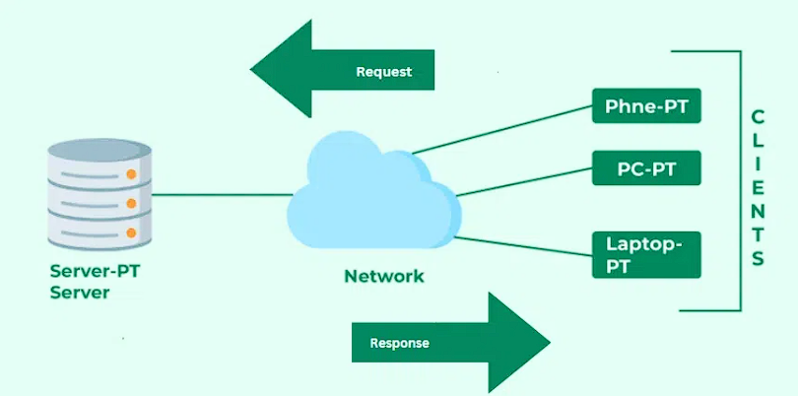

(8) Describe the roles of the client and server in web communication?

**Client**

* **Definition**: The client is typically a device or software (such as a web browser, mobile app, or other application) that sends requests to the server.
* **Role**:
  1. **Initiates Requests**: The client sends HTTP (Hypertext Transfer Protocol) or HTTPS (secure version) requests to the server for resources like web pages, images, or other content.
  2. **Displays Information**: Once the server processes the request and sends back a response, the client renders the received data, displaying it to the user in a readable format.
  3. **User Interaction**: Clients enable users to interact with websites or applications. For example, when a user enters a URL or clicks a button, it triggers a request to the server.
  4. **Sends Data**: Clients can also send data to servers, such as when submitting forms, logging in, or interacting with web applications.

**Example**: A web browser like Chrome or Firefox is a client. When you type a URL and hit Enter, the browser sends a request to the server hosting the website.

**Server**

* **Definition**: A server is a powerful computer or software system that listens for requests from clients and responds with the appropriate data.
* **Role**:
  1. **Receives Requests**: The server listens for incoming requests from clients, usually over the internet or a network.
  2. **Processes Requests**: After receiving a request, the server processes it. This may involve fetching files from its database or computing the response (such as running server-side code).
  3. **Sends Responses**: The server sends back a response to the client. This response often includes HTML pages, images, video files, or data in other formats (JSON, XML, etc.).
  4. **Manages Resources**: The server stores and manages resources like databases, files, or applications that clients request. It also handles tasks like authentication, security, and logging.

(9) Network Layers on Client and Server?

**ANS -Network layer**: Handles routing and sending data between different networks. It uses IP and ICMP protocols to assign source and destination IP addresses to packets.

(10) Describe the roles of the client and server in web communication.

ANS-In web communication, the client's role is to send requests to the server, and the server's role is to process those requests and send back the requested data or services.

(11)Explain the function of the TCP/IP model and its layers.

ANS -The TCP/IP model (Transmission Control Protocol/Internet Protocol) is a conceptual framework used to describe how data travels across a network. It is the foundation of the internet and networking protocols, dictating how devices communicate over a network, ensuring data is transmitted efficiently and reliably.

**Layers of TCP/IP Model**

Application Layer

Transport Layer(TCP/UDP)

Network/Internet Layer(IP)

Network Access Layer

(12)Client and Servers?

Client: A client is a device or application that requests services or resources from a server.

Server: A server is a device or application that provides services, resources, or data to clients.

(13)Explain Client Server Communication?

ANS-Client-server communication is a model where a client sends a request to a server over a network, and the server responds with the requested information or performs the requested action.

(14)Types of Internet Connections?

Dial-Up Connection.

Broadband Connection

DSL (Digital Subscriber Line)

Cable

Satellite Connection

Cellular

ISDN (Integrated Service Digital Network)

(15) How does broadband differ from fiber-optic internet?

Fiber-optic internet is a type of broadband that uses glass or plastic fibers to transmit data, while broadband is a general term for high-speed internet. Fiber-optic internet is faster, more reliable, and more secure than traditional broadband

(16) Protocols?

TCP/IP (Transmission Control Protocol/Internet Protocol),

UDP/IP (User Datagram Protocol/Internet Protocol),

HTTP (HyperText Transfer Protocol)

FTP (File Transfer Protocol)

(17)What are the differences between HTTP and HTTPS protocols?

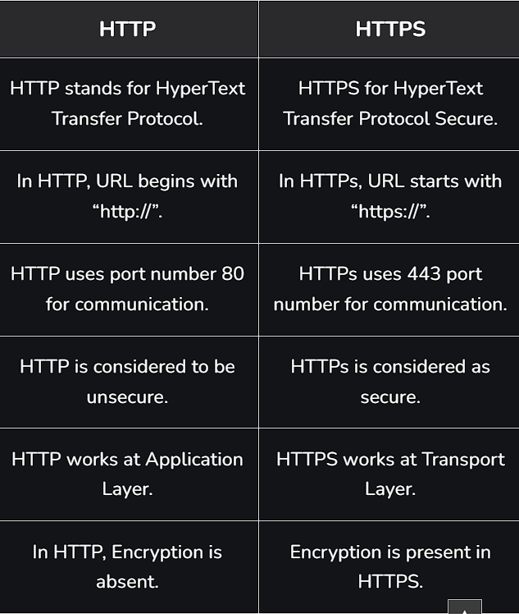

(18)What is the role of encryption in securing applications?

ANS - Data Encryption is an important part of preserving data integrity, and confidentiality, its importance cannot be overestimated. Almost the whole thing on the internet has been encrypted at some point. In this article, we will discuss data encryption and its importance.

(19) Software Applications and Its Types?

General Applications,

Business Applications,

Custom Developed Applications.

(20) What is the difference between system software and application software?

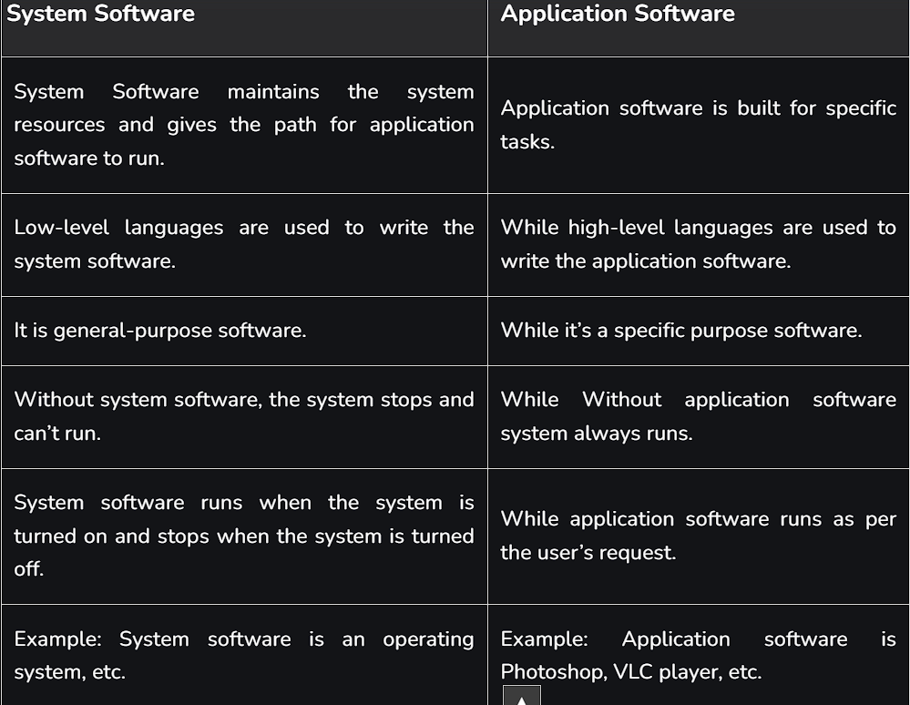

(21) Software Architecture?

Software architecture is the set of structures needed to reason about a software system and the discipline of creating such structures and systems.

(22) Whatis the significance of modularity in software architecture?

ANS- Modularity in software architecture is important because it improves the design, development, testing, and maintenance of software. Here are some benefits of modularity.

Code organization

Collaboration

Testing

Debugging

Scalability

Longevity

System efficiency.

(23) Layers in Software Architecture?

ANS- Here are five main layers in software architecture.

* 1. **Presentation layer.**
  2. **Application layer.**
  3. **Business layer.**
  4. **Persistence layer.**
  5. **Database layer.**

(24) Why are layers important in software architecture?

ANS-Layers are important in software architecture because they help organize code, improve maintainability, and facilitate testing.

(25) Software Environments ?

ANS-A software environment is a collection of programs, libraries, and utilities that allow users to perform specific tasks.

(26)Explain the importance of a development environment in software production?

ANS- A development environment is important in software production because it helps ensure the quality of the software and the efficiency of the developer.

**Improve productivity**

**Reduce errors**

**Improve software quality**

**Streamline the release process**

(27) Source Code?

ANS- a text listing of commands to be compiled or assembled into an [executable](https://www.google.com/search?sca_esv=91f0391296c51b34&sxsrf=ADLYWIJ-sizNe80lH6FfLW78j8XJ6vrseQ:1735296728688&q=executable&si=ACC90nyOnVY18Aw7zUtkWPYo5mTnO2HxjEX0WCPw7_lT8OHoWrQZZhoiu6aAFpC-Robl7Yo1QlzxG9FddwiwxqFwbHSjVt0qW0j_6lyUvhlOsijLrgG7g9E%3D&expnd=1&sa=X&ved=2ahUKEwjYk9-I5MeKAxW_cWwGHYH-AFsQyecJegQIHBAa) computer program.

(28) What is the difference between source code and machine code?

The main difference between source code and machine code is that source code is written by programmers in a human-readable language, while machine code is a set of instructions that a computer can directly understand.

* **Source code**

Written by programmers using high-level or intermediate languages, source code is easy to read and modify. Programmers can include comments in the source code to make it easier to understand.

* **Machine code**

Also known as machine language, machine code is a set of instructions that a computer's central processing unit (CPU) can directly process. Machine code is presented in binary format (0s and 1s)

(28) Github and Introductions?

GitHub is a web-based platform that helps developers manage and track code changes, and collaborate on projects.

(29) Why is version control important in software development?

ANS-The Version Control System helps manage the source code for the software team by keeping track of all the code modifications.

(30) Student Account in Github?

ANS-GitHub Education offers students real-world experience with free access to various developer tools from GitHub's partners.

(31) What are the benefits of using Githubforstudents?

**Benefits of the GitHub Student Developer Pack**

* Free GitHub Pro Account. With the GitHub Student Developer Pack, you receive a free GitHub Pro account for as long as you remain a student. ...
* Free Domain Name and Hosting. ...
* Free Cloud Services. ...
* Learning Resources. ...
* Developer Tools and Services.

(32) Types of Software?

There are different types of software that can run on a computer: system software, utility software, and application software.

(33) What are the differences between open-source and proprietary software?

ANS- Open-source software is distributed with its source code, and lets users freely inspect, modify, and enhance it per its licensing agreement, while proprietary software is the copyrighted property of an individual or company that limits its use, distribution, and modification by way of a proprietary license.

(34) GIT and GITHUB Training?

ANS- The “GIT” full form is “Global Information Tracker.

(35) How does GIT improve collaboration in a software development team?

ANS- Git improves collaboration in software development teams by enabling multiple developers to work on different branches simultaneously without overwriting each other's changes.

(36) Application Software?

ANS- Application software, also known as apps, is a type of computer program that helps users perform specific.

(37) What is the role of application software in businesses?

ANS- Application software plays a key role in businesses by helping companies perform tasks, manage operations, and make better decisions. Application software can help businesses.

(38) Software Development Process?

ANS- The Software Development Life Cycle (SDLC) consists of seven essential phases—Planning,

* Requirements Analysis
* Design
* Coding
* Testing
* Deployment
* Maintenanc

(39) What are the main stages of the software development process?

ANS- The Software Development Life Cycle (SDLC) consists of seven essential phases—Planning,

* Requirements Analysis
* Design
* Coding
* Testing
* Deployment
* Maintenanc

(40) Software Requirement?

ANS- Software requirements typically break down into

 functional requirements,

nonfunctional requirements (NFRs)

domain requirement.

(41) Why is the requirement analysis phase critical in software development?

ANS-The purpose of requirements analysis is to be sure all product requirements accurately represent stakeholder needs and requirements.

(42) Software Analysis?

ANS- Software analysis is basically a requirement analysis that aims to determine the tasks that are needed to get fully functional software.

(43) What is the role of software analysis in the development process?

ANS-The role of software analysis in the development process.

* **Capture requirements**: Understand the business needs of the software, including the needs of stakeholders.
* **Analyze requirements**: Document and validate the requirements.
* **Create a detailed specification**: Create a detailed specification for the product that developers can use.
* **Decompose the project**: Break down the project into smaller components that can be reused
* **Represent the logic**: Represent the program's logic using diagrams, pseudocode, and other tools.
* **Model legacy software**: If the project uses legacy software, model it to ensure it integrates correctly with the new software.

**(44)** **System Design?**

ANS-Systems Design is the process of defining the architecture, components, modules, interfaces, and data for a system to satisfy specified requirements.

(45) What are the key elements ofsystem design?

* Architecture. The architecture of a system defines its structure and behavior. ...
* Database Design. ...
* APIs and Communication. ...
* Caching. ...
* Load Balancing. ...
* Security. ...
* Scalability and Performance. ...
* Redundancy and Fault Tolerance.

(46) Software Testing?

ANS-Software testing is the process of assessing the functionality of a software program.

(47) Why is software testing important?

ANS-Software testing is imperative, as it identifies any issues and defects with the written code so they can be fixed before the software product is delivered.

(48) Maintenance?

ANS-Software maintenance is the process of changing, modifying, and updating software to keep up with customer needs?

(49) What types ofsoftware maintenance are there?

ANS-

* Corrective Software Maintenance. Corrective software maintenance is the typical, classic form of maintenance (for software and anything else for that matter). ...
* Preventative Software Maintenance. ...
* Perfective Software Maintenance. ...
* Adaptive Software Maintenance.

(50) Development?

ANS- Development is a process that creates growth, brings in progress and positive change.

(52) What are the key differences between web and desktop applications?

ANS-

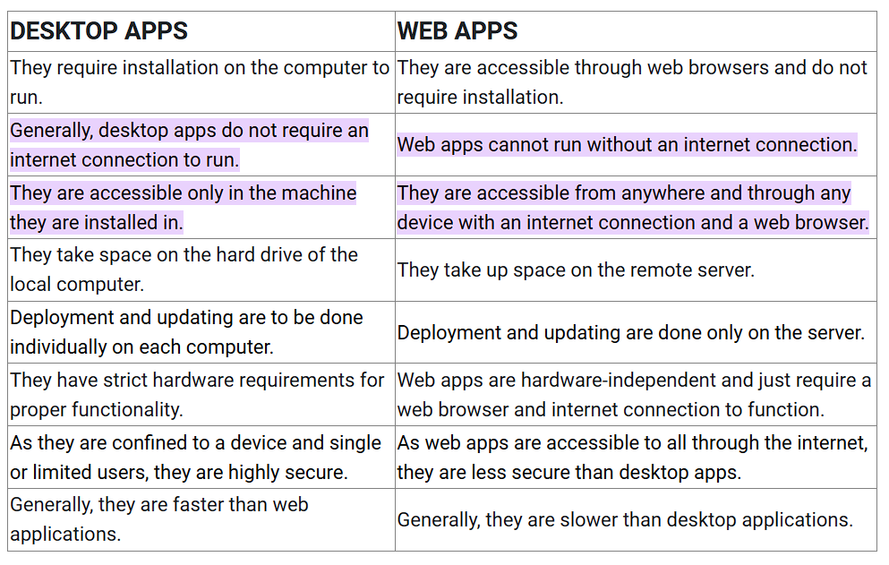

(53) Web Application?

ANS- A web application, or web app, is a software program that runs in a web browser and is accessed over the internet.

(54)What are the advantages of using web applications over desktop applications?

ANS- **The Advantages of Web Applications - 8 Reasons Why You Should Convert Now**

* No software installation. ...
* Automatic updates. ...
* Cross-platform compatibility. ...
* Light on system resources. ...
* 24/7 access to data. ...
* Better user interfaces. ...
* Potential for Integration. ...
* Scalability.

(55) Designing?

ANS- Design in technology refers to the practice of creating a technological result, as well as defining its physical and functional characteristics.

(56) What role does UI/UX design play in application development?

ANS-UI/UX design is a critical part of application development because it affects the user experience, accessibility, and overall success of the app.

(57) Mobile Application?

ANS -A mobile application, or mobile app, is a computer program designed to run on smartphones, tablets, and other mobile devices.

(58) What are the differences between native and hybrid mobile apps?

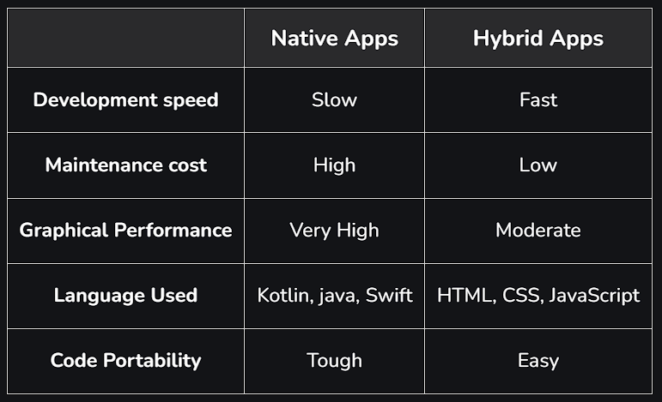

(60) DFD (Data Flow Diagram)?

ANS- A data flow diagram (DFD) maps out the flow of information for any process or system.

(61) What is the significance of DFDs in system analysis?

ANS-Data flow diagrams (DFDs) are a vital tool in system analysis because they provide a visual representation of a system's processes, data flows, and other components.

(62) Desktop Application?

ANS- A desktop application is a software program that runs on a computer, either a laptop or a PC.

(63) What are the pros and cons of desktop applications compared to webapplications?

ANS- Generally, desktop applications tend to perform faster because they run directly on the user's machine, while web applications depend on internet speed and server performance.

(64) Flow Chart?

ANS- A **flowchart** is a type of diagram that represents a workflow or process. A **flowchart** can also be defined as a diagrammatic representation of an algorithm.

(65) How do flowcharts help in programming and system design?

ANS-For programmers, flowcharts serve as a roadmap for writing code. They allow programmers to break down a complex problem into smaller, more manageable steps. This helps them identify potential issues or bottlenecks in the program's logic.